A Report on Major Project

Employee productivity monitoring system using a hybrid deep learning-based detection and activity tracking.
SUBMITTED IN FULFILLMENT OF THE REQUIREMENTS FOR THE DEGREE OF

BACHELOR OF TECHNOLOGY
IN

ELECTRONICS AND TELECOMMUNICATION ENGINEERING
OF

VISHWAKARMA INSTITUTE OF TECHNOLOGY
Savitribai Phule Pune University
BY

Uday Dandekar (12211606)
Shivam Dhokane (12210398)
Megha Derkar (12211174)

UNDER THE GUIDANCE OF

Prof. Dr. Shital Pawar



DEPARTMENT OF ELECTRONICS AND TELECOMMUNICATION

BANSILAL RAMNATH AGARWAL CHARITABLE TRUST’S

VISHWAKARMA INSTITUTE OF TECHNOLOGY
(An Autonomous Institute affiliated to Savitribai Phule Pune University)

PUNE – 411037
2025–2026

Bansilal Ramnath Agarwal Charitable Trust’s

Vishwakarma Institute of Technology, Pune – 37
(An Autonomous Institute Affiliated to Savitribai Phule Pune University)


CERTIFICATE

This is to certify that the Project Report entitled Employee productivity monitoring system using a hybrid deep learning-based detection and activity tracking has been submitted in the academic year 2025-26 by
Uday Dandekar Roll No. 18 Shivam Dhokane Roll No. 26
Megha Derkar Roll No. 20
under the supervision of Prof. Dr. Shital Pawar in partial fulfillment of the requirements for the degree of Bachelor of Technology in Electronics and Telecommunication Engineering as prescribed by Savitribai Phule Pune University.

Guide/Supervisor Head of the Department
Name: Prof. Dr. Shital Pawar Name: Prof. Dr. Medha Wyawahare
Signature: Signature:

External Examiner
Name:
Signature:

Acknowledgment
We would like to express our deepest gratitude and appreciation to all those who have contributed to the successful completion of our project thesis, titled “Employee productivity monitoring system using a hybrid deep learning-based detection and activity tracking,” conducted at Vishwakarma Institute of Technology, Pune.
First and foremost, we extend our heartfelt thanks to Prof. Dr. Shital Pawar, our project guide, for her invaluable guidance, support, and expertise throughout the project. Her unwavering encouragement, insightful feedback, and dedication were instrumental in shaping our research and ensuring its successful execution.
We would like to thank our HOD, Prof. Dr. Medha Wyawahare, for her support and steadfast encouragement, thoughtful feedback, and unwavering dedication, which played a crucial role in shaping our research and guiding it to successful completion.
We would like to express our gratitude to the faculty and staff of Vishwakarma Institute of Technology for providing us with the necessary resources, infrastructure, and academic environment to carry out our research effectively.

Abstract:
The Placify is an AI-powered placement preparation platform designed to provide a unified learning environment for students preparing for technical interviews. The system integrates automated content generation, real-time code execution, and personalized performance analytics to simulate industry-level coding assessments. Users authenticate through a secure login system, after which they can request company- and topic-specific coding questions. Using the Gemini API, Placify dynamically generates interview-style problems across multiple difficulty levels, along with structured starter code and comprehensive test cases.
The platform enables candidates to write and execute their solutions directly within the browser. Submitted code is compiled and executed on the server using a subprocess-based Java execution pipeline, and the results are evaluated against auto-generated test cases to determine correctness. All user activities—including time spent, attempts, scores, and code submissions—are stored in MongoDB and visualized through analytical dashboards. These dashboards provide insights into skill growth, topic-wise strengths, difficulty distribution, and learning patterns. Additional features such as memory and reaction-time games contribute to cognitive improvement and are also logged for skill tracking.
By combining AI-driven question generation, automated execution, and data-centric learner insights, Placify delivers a complete and adaptive placement preparation ecosystem. The platform enhances personalized learning, improves assessment efficiency, and provides a realistic coding interview experience, thereby supporting students in strengthening their problem-solving abilities and increasing their chances of success in technical hiring processes.

INDEX

CHAPTER 1 - Introduction 1
  - Background
  - Need for Integration
  - User Experience and Learning Ergonomics
  - Methodology Overview
  - Significance of the Project
CHAPTER 2 - Literature Review 4
CHAPTER 3 - Methodology 7
  - System Overview
    - Dynamic Generation (Input Phase)
    - Automated Execution (Processing Phase)
    - Data-Driven Feedback (Output Phase)
  - System Architecture (Structural Design & Interactions) 9
    - Presentation Layer (Frontend)
    - Application Logic Layer (Backend)
    - Data Storage Layer (Database)
  - System Architecture (Structural Design & Interactions)
  - Data Flow and Tracking 10
    - Question Generation Flow (Input Phase)
    - Code Execution Flow (Processing Phase)
    - Performance Tracking Flow (Storage Phase)
  - Data Processing (Cleaning, NLP, AI) 12
    - AI and NLP Integration
    - Data Cleaning and Filtering
    - Structured Data Extraction
  - System Modules / Subsystems 14

    - User Interface (Frontend) Module
    - Authentication and Security Module
    - AI Content Generation Module
    - Code Execution Engine (The Judge)
    - Data Management Module (Database Layer)
    - Analytics and Reporting Module
  - Backend Architecture and Logic 16
    - Request Handling and API Integration
    - The Code Execution Logic (The Judge)
    - Session Management and State Persistence
    - Temporary File Lifecycle Management
    - Subprocess Orchestration Layer
    - Input Sanitization and Regex Parsing Logic
  - Storage and Data Management (Database Design) 18
    - User and Authentication Data
    - Submission and Activity Logs
    - Cognitive and Quiz Data
  - Workflow / Step-by-Step Process (Operational Flow)
    - Session Initialization and Context Setting
    - AI-Driven Content Generation and Parsing
    - Code Construction and Submission
    - Sandboxed Execution and Evaluation
    - Feedback Loop and Data Aggregation

Chapter 4 Results 22
Chapter 5 Result Analysis 23
    - Performance and Latency Analysis

    - Reliability of Unstructured Data Parsing
    - Pedagogical Impact and Engagement
    - Security and Isolation Assessment

Chapter 6: Conclusion and Future Scope 26
References: 29

List of Figures

Fig. 1. System Architecture Flowchart 7
Fig. 2. User Process Tracking 9
Fig. 3. Topic-Based Question Preparation 11
Fig. 4. Java Memory Card Game 15
Fig. 5. User Engagement: Gamified vs. Non-Gamified 23
Fig. 6. Code Submission Outcome Distribution 24

Chapter 1: Introduction

Background:
In recent years, the demand for skilled software professionals has increased significantly due to the rapid growth of digital technologies and automation in industry. Engineering and technical colleges now emphasize placement readiness, but students still face fragmented learning environments. Typically, coding practice, aptitude tests, company-specific preparation, and performance analysis are spread across multiple platforms, making the learning process inefficient and unstructured.
Most training platforms provide static question banks that do not adapt to individual strengths, weaknesses, or learning pace. Additionally, students do not receive real-time feedback comparable to industry coding assessments, which affects their ability to improve effectively before recruitment drives. With advancements in artificial intelligence and cloud-based development, there is an opportunity to create an integrated, intelligent, and adaptive system that provides everything a student needs for placement preparation in one place.
Placify addresses this need by offering a unified and AI-driven platform where users can generate company-specific questions, execute code online, analyze performance, and track progress continuously. The system leverages modern technologies such as Gemini AI, MERN stack architecture, dashboards, and data analytics to simulate real recruitment environments and help students strengthen their technical readiness.

Need for Integration:
The traditional approach to placement preparation requires students to navigate multiple platforms for different learning activities, such as coding practice, aptitude learning, online compilers, interview questions, and performance tracking. This creates a scattered and disconnected learning experience, making it difficult for learners to maintain consistency, continuity, and measurable improvement over time.
Many platforms provide large question pools, but they lack personalization and adaptability. Students with different academic backgrounds and learning speeds often end up following the same linear content pathway without targeted guidance or feedback. Moreover, conducting separate assessments and tracking individual growth manually becomes time-consuming for both students and training coordinators. As a result, the overall learning process becomes inefficient and less effective.
An integrated system is necessary to unify these components into one platform, where AI can dynamically generate company-specific questions,

automatically evaluate code, and track student performance centrally. By merging content delivery, execution environment, and analytics into a single solution, Placify ensures a smoother workflow, continuous learning, and data-driven improvement. This integration not only reduces time and effort but also supports a structured and holistic preparation strategy that reflects real industry expectations.

User Experience and Learning Ergonomics:
Effective learning depends not only on the quality of content but also on how comfortably and efficiently users can interact with the platform. Many existing preparation tools overload students with complex interfaces, advertisements, cluttered navigation, or disjointed workflows, which increases cognitive load and reduces learning efficiency. Students often spend more time switching between systems than focusing on concepts and problem-solving.
Placify emphasizes a streamlined user experience designed to reduce friction and enhance productivity. The platform provides a clean and focused interface where users can log in, request customized questions, write code, execute solutions, and view performance analytics—all without leaving the environment. This eliminates unnecessary distractions and ensures that students remain immersed in the learning process.
Ergonomic learning principles such as minimal clicks to complete tasks, clear visual hierarchy, real-time response feedback, and continuous progress visibility guide the system’s design. Integrated coding editors, instant evaluation, dashboards, and engaging mini-games further ensure that learning remains interactive, motivating, and psychologically comfortable. By optimizing the interaction design, Placify supports better retention, reduces stress during preparation, and mimics the focused environment expected in real technical assessments.

Methodology Overview:
Placify follows a structured methodology that integrates AI-generated problem creation, online code execution, and performance analytics into a unified learning system. The process begins with user authentication, where students securely log into the platform and access personalized dashboards. Once logged in, students can request placement-oriented questions based on preferred difficulty levels, topics, or specific companies. These questions are generated using the Gemini AI API, ensuring relevance, variability, and industry-focused patterns.
The system then provides a browser-based coding editor where users write and run their solutions. Behind the scenes, the user’s code is processed and executed on the server using a secure subprocess-based Java execution pipeline. The output is

automatically compared with predefined test cases generated by the AI model to determine correctness.
This enables real-time evaluation similar to professional coding assessment platforms. Throughout the process, student interaction data—including attempts, execution results, time spent, and improvement trends—is continuously recorded in the backend database (MongoDB). This data powers analytical dashboards that display performance insights such as accuracy rates, difficulty progress, topic mastery, and skill development over time. Additional cognitive reinforcement is offered through integrated memory and reaction games, with progress metrics also tracked and visualized.
This methodology ensures a seamless feedback loop where learning, practice, evaluation, and improvement occur within the same platform, leading to a structured and highly adaptive preparation experience.

Significance of the Project:
The significance of Placify lies in its ability to bridge the gap between traditional placement preparation methods and modern AI-driven adaptive learning systems. Conventional training approaches often rely on static question banks, manual evaluations, and limited performance feedback, which can hinder personalized skill development. Placify transforms this experience by dynamically generating interview-style problems tailored to a learner’s level, interests, and target companies, ensuring that preparation remains relevant and engaging.
By integrating real-time code execution and automated evaluation, Placify provides students with instant feedback similar to industry-grade online assessment platforms used by companies during recruitment. This immediate validation not only reinforces conceptual understanding but also helps students iteratively refine their approach and logic without the need for manual intervention.
Furthermore, the platform’s detailed analytics give learners visibility into their progress through metrics such as accuracy, improvement trends, topic-wise strengths, and time management patterns. These insights enable students to adopt purposeful and data-driven study strategies rather than relying on guess-based preparation. To support holistic development, Placify also incorporates cognitive skill-enhancing mini-games that improve focus, reaction speed, memory retention, and exam-time decision efficiency. By tracking performance across intellectual and cognitive dimensions, the platform promotes well-rounded preparation tailored to real placement needs.
Overall, Placify represents a meaningful shift toward personalized, scalable, and intelligence-augmented learning that enhances placement readiness, boosts confidence, and empowers students to excel in competitive technical interviews.

Chapter 2: Literature Review

The conventional method of interview preparation is typically peer-to-peer mock interviews, static questionnaires, or mentor advice. These may be limited in availability, personalization, and scalability. To overcome these constraints, the researchers proposed AI-based platforms that conduct mock interviews, assess candidate performance, and provide instant feedback. Patil et al. suggested an AI human-powered mock interview coach that can adapt question difficulty and tailored tone based on natural language candidate response processing (NLP) [1]. Their model replicates actual interview dynamics of adaptive questioning and real-time feedback generation and constant feedback; hence, the mock interview experience is more realistic and personalized to users. The review by an anonymous author in the International Research Journal crosses the AI landscape of driven mock interview websites, seeking required components like question generation, sentiment analysis algorithms, and response scoring [2]. It differs from rule-based, more advanced large language model (LLM)-based platforms, whose utilization of resources like GPT and Gemini enhances interaction quality. Patil authored the role of AI in interview preparation to shift suggesting systems based on deep learning for emotional intelligence analysis. This article emphasizes the importance of recognizing candidate stress, speech fluency, and behavior patterns to generate personalized feedback, which helps holistic interview preparedness [3]. In a companion work, Patil focused on mastery-based evaluation with AI interview guides. The system utilizes NLP and facial emotion analysis to evaluate verbal and non-verbal conduct, generating rich performance descriptions of candidates, a crucial step towards scalable soft skill evaluation [4].
Patil highlighted the AI role in enabling candidate success by providing smart preparation modules that learn to adapt over time. The system demonstrated in this work tracks learning, provides behavioral suggestions, and adjusts interview difficulty, creating a dynamic and responsive mock interview environment [5]. Patil et al, in their 2025 work, presented an end-to-end AI mock interview platform with psychological readiness modules and technical testing [6]. The system integrates NLP, emotion analysis, and feedback loops, aligning interview training with real-world expectations and improving candidate performance consistency. Liu created "Interview AI-ssistant," a collaborative system where users can choose the level of AI support [7]. The platform integrates human intuition and machine learning feedback in real-time and enables personalized interview preparation while maintaining user agency—a new paradigm in adaptive interview coaching. Daryanto et al. [8] introduced "Conversate," a reflective learning platform that simulates interview scenarios and provides dialogic feedback [9].

By prompting users to self-evaluate before receiving automated critique, the system fosters deeper learning and encourages candidates to refine their answers through introspection and system-aided guidance. Wang et al. explored learner behavior on online programming platforms, emphasizing how adaptive difficulty and immediate feedback shape student engagement. Their study demonstrated that personalized suggestions and performance monitoring greatly improved learning performance in Python environments [10]. In another previous study, an anonymous author contrasted interactive programming environments for students, with higher motivation and retention of knowledge [11]. The biggest strength of the platform was the gamified problem-solving environment that combined real-time execution with monitoring of progress to allow students to develop coding confidence. A 2024 study by ResearchGate assessed the effectiveness of interactive websites in computer programming education. The findings show that such platforms enhance student comprehension by iterative feedback, challenge-based learning, and peer comparisons reorganizing the conventional curriculum delivery [12].
Guo and Zhang of the University of Washington built predictive models that evaluate student performance based on time-on-task patterns and error data. These results allowed for individualized interventions and skill-based question generation, building computer programming education adaptive learning methods [13]. A Nankai University case study recorded the use of virtual labs to facilitate sustainable higher learning. These labs offered coding areas with analytics dashboards, which allow teachers to view participation while providing students with access to high-quality, interactive simulations and automated feedback [14]. A TELRP study implemented an integrated Python training system that offers comprehensive real-time validation and guidance. Students under this system were given line-by-line comments, encouraging systematic thinking and enabling continuous coding practice at scale [15]. An earlier work reported an online system that aimed to improve coding proficiency with interactive modules. Through the use of repetition, cues, and performance history, the system accommodated novices and intermediates, showing the scalability of formal coding education [16].
An arXiv work suggested an adaptive scaffolding model for block-based programming environments. These environments added pop quizzes and logic questions based on students' prior code, which emphasized structural mistakes and enforced programming concepts for younger students [17]. Fang et al. created ClassCode, an instructional, classroom-oriented collaborative coding tool. Teachers could observe students' activity in real-time, give instantaneous feedback, and intervene on code sessions, building an active hybrid model that complemented instructor supervision with independent learning [18]. Western Carolina University tested Big Interview, a hybrid AI-powered platform that combined technical coding walkthroughs with behavioral interview simulations. This model eliminated the gap between hard and soft skill training by

providing scenario-based practice in both areas [19]. Lastly, A systematic review in Smart Learning Environments investigated how learning analytics in virtual labs influence students' achievements. It concluded that adaptive interventions, fueled by analytics engines, significantly impact learning outcomes, enabling teachers to tailor content and assessment [20].

Chapter 3: Methodology

System Overview
The methodology adopted for the development of Placify centers on the integration of Generative Artificial Intelligence (AI) with a traditional web-based Learning Management System (LMS). Unlike conventional platforms that rely on static, pre-defined databases of questions, Placify utilizes a Dynamic Content Generation approach. The system is designed to function as an autonomous educational agent that not only provides learning materials but also evaluates student performance in real-time.
The system operates on a cyclic "Generate-Evaluate-Analyze" workflow:
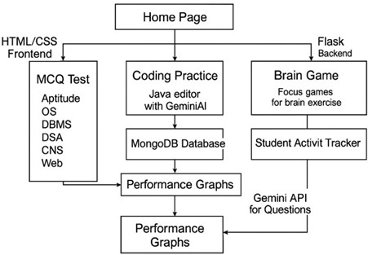

Fig. 1.System Architecture Flowchart
This Fig-a illustrates the system architecture flowchart of a web-based learning platform that begins at a central Home Page and branches into three main functional areas managed by frontend (HTML/CSS) and backend (Flask) technologies. It features MCQ Tests covering various computer science subjects, Coding Practice equipped with a Java editor integrated with GeminiAI and backed by a MongoDB database, and Brain Games designed for focus exercises linked to a Student Activity Tracker and the Gemini API for question generation.

The outcomes and data from all three modules—technical quizzes, AI-assisted coding

challenges, and cognitive activities—ultimately converge to generate comprehensive Performance Graphs, providing visual analytics of the student's progress across different domains.

Dynamic Generation (Input Phase):
The system eliminates the need for manual data entry of coding problems. By leveraging the Google Gemini API, the application dynamically constructs problem statements, input/output constraints, and hidden test cases based on the user's specific requirements (e.g., "Medium-level Array questions asked in TCS"). This ensures that the content remains current and unlimited.

Automated Execution (Processing Phase)
To simulate a realistic technical interview environment, the system incorporates a backend Code Execution Engine. When a user submits a solution (specifically in Java), the system captures the code, compiles it in a secure, isolated sub-process, and validates it against the AI-generated test cases. This removes the need for human intervention in grading.

Data-Driven Feedback (Output Phase)
The final stage of the methodology focuses on retention and improvement. All interaction data—including compilation errors, runtime execution speed, and topic success rates is stored in a non-relational database (MongoDB). This data is processed to generate visual analytics, providing the user with immediate feedback on their technical strengths and cognitive performance (via integrated Brain Games).
This architecture moves away from the traditional "CRUD" (Create, Read, Update, Delete) model and adopts an AI-orchestrated model, where the application logic acts as a bridge between the user's learning needs and the Large Language Model's capabilities.

System Architecture (Structural Design & Interactions)
Placify is built using a modular three-tier architecture, which clearly separates the user interface, the application logic, and the data management components.
This architectural choice ensures that each layer can function independently while still interacting seamlessly with the others. By structuring the system in this format, Placify becomes easier to maintain, scale, and debug, as updates in one layer do not disrupt the others. The architecture also supports smooth performance even as user load increases because each tier can be optimized or expanded separately without affecting the overall workflow.

Presentation Layer (Frontend)
The Presentation Layer acts as the communication bridge between the system and the user, ensuring that all interactions are intuitive and visually clear. Built using HTML5, CSS3, and JavaScript, this layer provides the interface where learners write and execute code, attempt quizzes, and review their performance analytics. A custom code editor allows users to type, modify, and run Java programs directly within the browser, while the analytics dashboard uses Chart.js to render dynamic visual graphs showcasing accuracy trends, progress over time, and user-specific performance indicators. The UI follows ergonomic and usability principles, ensuring minimal cognitive load and smooth navigation across modules, making the learning experience efficient and user-friendly.
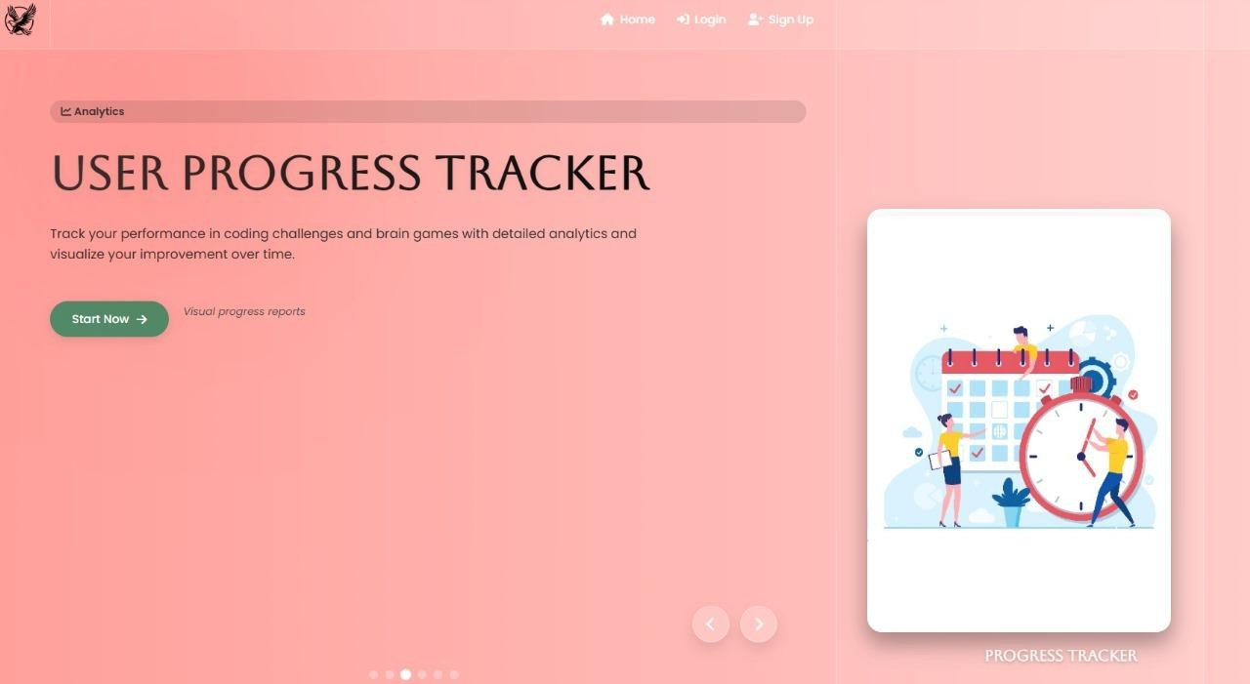
Fig. 2. USER PROGRESS TRACKING

Application Logic Layer (Backend)
The Application Layer forms the core processing engine of Placify and handles the operational logic required to process requests from the frontend. Developed using Python and the Flask framework,
it manages routing, session control, and the overall coordination between the AI engine, the code execution module, and the database. The AI Integration Module enables seamless communication with the Google Gemini API, allowing Placify to generate dynamic coding problems, provide explanations, and build relevant test cases tailored to user performance. The backend also includes a secure Code Execution Engine, which compiles and runs Java code inside a controlled subprocess environment, ensuring that user programs are evaluated safely and accurately. This layer ensures that every interaction—whether generating a question or evaluating code—is processed efficiently and precisely.

Data Storage Layer (Database)
The Data Layer is responsible for storing all persistent information required for delivering personalized learning experiences. Implemented using MongoDB, this layer maintains structured collections for user authentication details, submission logs, activity histories, and performance metrics. The User Collection stores all registered accounts with securely hashed passwords, while the Submissions Collection records every attempt made by users, capturing details such as input, output, execution time, pass/fail status, and timestamps. Additional tracking documents store session durations, interaction frequencies, and behavioral patterns that support future analytics and insights. By using a flexible NoSQL structure, the database supports scalable growth as more learners interact with the system, ensuring fast retrieval and efficient data querying.

Data Flow and Tracking
Placify handles a continuous exchange of information between the user, the AI model, the backend logic, and the execution engine. To ensure that this interaction remains efficient, secure, and well-organized, the system follows a structured data flow pipeline. This pipeline operates across three major phases—Question Generation, Code Execution, and Performance Tracking each of which transforms user input into meaningful learning outcomes. The flow ensures that every step, from selecting a topic to evaluating a code submission, is tracked, validated, and stored with complete data integrity. Internally, these processes work together to provide instant feedback, maintain historical accuracy, and support the adaptive features of the platform.

Question Generation Flow (Input Phase)
The data flow begins when a user initiates a learning session by selecting a specific topic and a target company. Once these parameters are provided, the Flask backend constructs a structured prompt that embeds the topic, company name, required difficulty levels, and the expected output format.
This prompt is then sent to the Google Gemini API, which generates a customized coding problem. The response returned by the AI is typically unstructured, containing descriptions, examples, explanations, and constraints.
To convert this raw information into a machine-readable format, the backend applies Regular Expressions that identify key sections of the response. The system extracts the final problem description, input-output specifications, and constraints, ensuring uniform formatting across all difficulty levels. The hidden test cases generated by Gemini are also isolated and restructured into JSON objects so that they can be executed during validation. Finally, the platform generates or retrieves starter code suited to the problem statement and saves all these elements in the user’s session. This marks the completion of the data input phase.
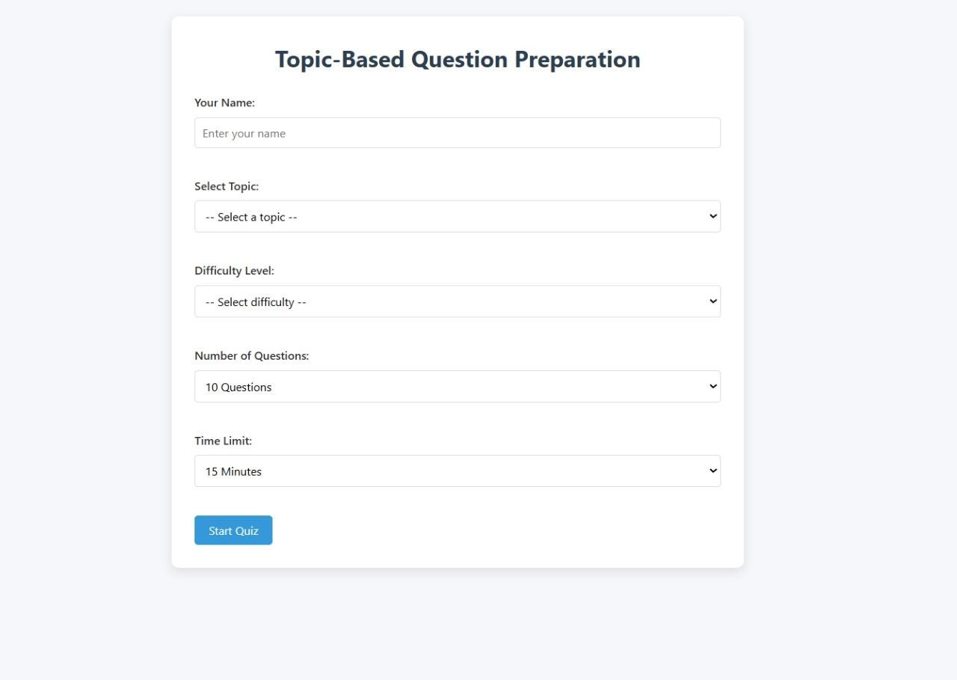
Fig. 3. TOPIC-BASED QUESTION PREPARATION

Code Execution Flow (Processing Phase)
Once the user writes and submits their solution, Placify enters the processing phase, which focuses on secure and isolated code execution. The submitted Java code is not executed directly; instead, the backend wraps it inside a standardized Main.java structure. This wrapper automatically integrates the hidden test cases obtained during the generation phase, ensuring that every submission is evaluated uniformly.

To safely compile and run the code, the platform uses Python’s tempfile module to create a temporary Java file. This approach prevents interference among different users' files and ensures session isolation. The backend then spawns a subprocess to compile the code using javac. If any compilation errors arise, they are captured and returned immediately to the user. If the compilation succeeds, a second subprocess runs the resulting class file.
The program’s output is captured from stdout and compared line-by-line against the expected outputs generated by the AI. This validation process ensures that logical errors, runtime errors, and edge-case failures are all detected precisely.

Performance Tracking Flow (Storage Phase)
After execution is complete, the system moves into the storage phase, where all results and metadata are securely logged for long-term tracking. Each submission is serialized and stored in the submissions collection within MongoDB, along with details such as the pass/fail status, encountered errors, and total execution time. This ensures that the platform maintains a complete historical record of the user’s learning trajectory.
Simultaneously, the process_tracking collection records timestamps, allowing the system to compute the total time spent in the session and track behavioral patterns such as study consistency and productivity. Once stored, these records become immediately available to the analytics subsystem, which updates graphs and dashboards in real time. The updated analytics—covering areas such as topic mastery, accuracy trends, and daily activity—give users a clearer understanding of their progress and areas requiring improvement.

Data Processing (Cleaning, NLP, AI)
Data processing within Placify is an essential step that transforms the unstructured, verbose, and occasionally inconsistent outputs received from both the user and the Gemini AI model into structured data suitable for execution, evaluation, and storage. Because the system depends heavily on AI-generated content—such as coding questions, test cases, and starter code—it must handle variations in formatting and language with high precision. Placify therefore employs a layered processing pipeline that integrates Natural Language Processing, stringent cleaning mechanisms, and structured data extraction routines. This ensures that all information passing through the backend maintains consistency, accuracy, and compatibility with the code execution engine.

AI and NLP Integration
At the foundation of Placify’s processing flow is its integration with the Google

Gemini API, which acts as a powerful NLP engine capable of interpreting context-rich prompts and generating highly tailored coding problems. When a user selects parameters such as topic, company, or difficulty level, the backend constructs a detailed prompt that captures these requirements along with instructions for formatting. Gemini then processes this prompt with an understanding that goes beyond keyword recognition—it analyzes semantic relationships, interview-style expectations, and technical phrasing.
As a result, the problems generated are not generic but closely resemble real-world placement questions, complete with structured descriptions, constraints, examples, and relevant edge cases.
The strength of this NLP integration lies in its contextual reasoning. The AI not only produces grammatically correct and logically coherent content but adapts its response style to fit an interview-oriented environment. This ensures that each question is technically accurate, concise, and aligned with the standards commonly observed in coding assessments conducted by major tech companies. Thus, AI-driven NLP serves as the foundation upon which the rest of the processing pipeline builds.

Data Cleaning and Filtering
Because generative AI models occasionally include conversational phrases or unnecessary formatting, the raw output cannot be used directly. Placify therefore implements a rigorous cleaning process designed to strip away noise and retain only essential segments of the AI response. This process begins with systematic scanning using Python’s Regular Expressions, which detect and remove filler statements such as “Here is your answer” or “Sure, I can help.” These artifacts, if left unfiltered, could disrupt the user interface or interfere with backend logic.
Markdown formatting is another common issue encountered in AI responses, especially in code-related outputs. To prevent compilation errors, the backend removes Markdown syntax such as triple backticks, fenced code blocks, and language identifiers like java or json. Beyond formatting cleanup, the system performs code-level sanitization to ensure that the extracted Java solution adheres to the required structure—particularly that it defines a class named Solution and does not introduce package declarations or conflicting class names. These checks guarantee that the user’s code, once combined with the system wrapper, will compile reliably within the controlled execution environment.

Structured Data Extraction
Once the data has been cleaned and filtered, the backend proceeds to extract and transform specific components into structured formats that the system can process programmatically. Hidden test cases produced by the AI are isolated from the main

text and converted into JSON-like Python structures. By parsing this information into lists of dictionaries, the platform ensures that each test case—along with its input method call and expected output—can be executed iteratively inside the wrapped Main.java file.
Similarly, constraints and problem descriptions are separated into distinct fields so that they can be displayed clearly in the UI.
The system ensures that every problem contains a well-defined set of constraints, formatted examples, and a method signature that is compatible with the starter code. This structured extraction not only enhances the user experience but also ensures that the backend has the precise data required for evaluation, validation, and analytics.

System Modules / Subsystems
The Placify platform is designed as a composite of several distinct, interconnected modules that work in unison to deliver a seamless learning experience. This modular architecture ensures a clean separation of concerns, allowing for independent development, testing, and scaling of individual components. By isolating functionality—such as the user interface from the logic of code execution—the system remains robust and easier to maintain.
The core subsystems of Placify are detailed below:

User Interface (Frontend) Module
The User Interface (UI) Module serves as the primary touchpoint for the user, operating entirely on the client side within the web browser. Built using HTML5, CSS3, and JavaScript, this module is responsible for rendering the visual structure of the application, including the landing page, the interactive dashboard, and the integrated code editor. Beyond mere display, it handles all user interactions, capturing inputs such as login credentials, topic preferences, and code submissions. It dynamically updates the view based on server responses, displaying real-time feedback from code execution and rendering complex performance data into intuitive charts via Chart.js, ensuring a responsive and engaging user experience.

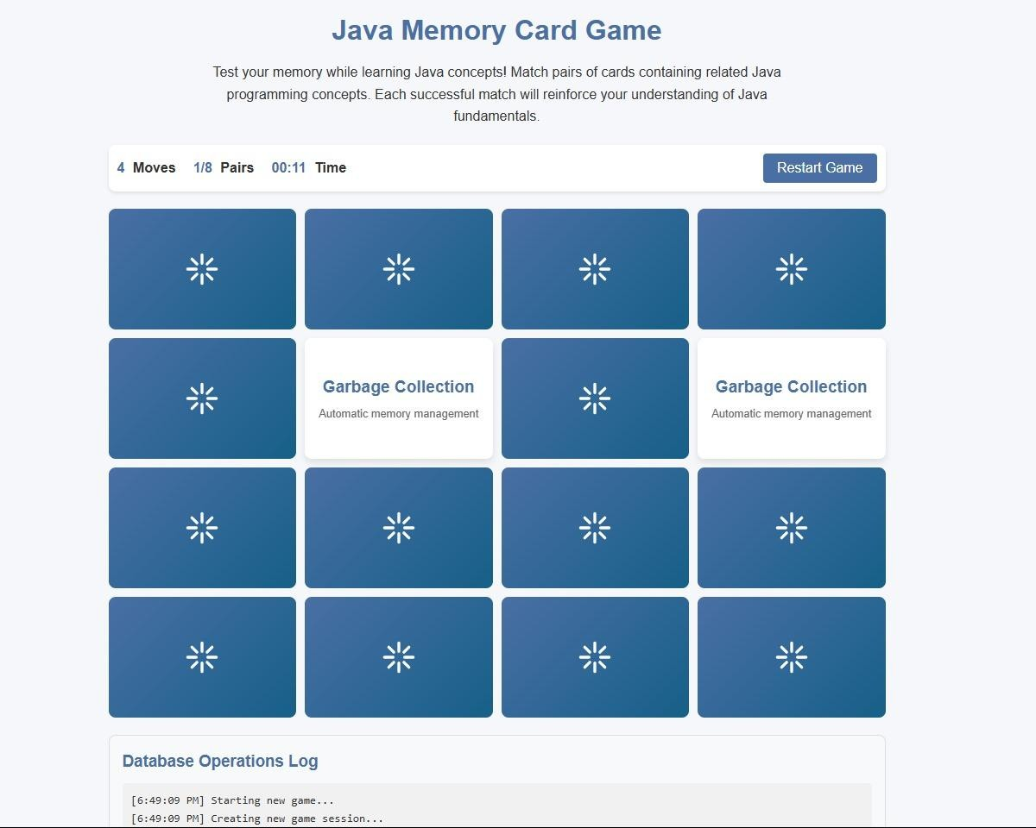
Fig. 4. JAVA MEMORY CARD GAME

Authentication and Security Module
The Authentication and Security Module acts as the gatekeeper of the system, dedicated to managing user identities and protecting sensitive data. Its primary function is to handle the lifecycle of user access, from initial registration to secure login processes. To safeguard user credentials, this module implements industry-standard encryption, specifically hashing passwords using algorithms like Bcrypt or SHA-256 before they are committed to the database. Furthermore, it manages active user sessions, ensuring that a user’s state is securely maintained across different pages of the application without requiring repeated logins, thereby balancing security with user convenience.

AI Content Generation Module
This module functions as the intelligent bridge between the Placify application and the external Gemini API. It is responsible for the dynamic creation of learning materials based on user-defined parameters. When a user selects a specific topic and difficulty level, this module constructs a tailored prompt and sends it to the AI service. Upon receiving the raw response, it performs critical parsing and sanitization operations to convert the unstructured text into a structured format. This includes extracting the problem description, constraints, and JSON-formatted test cases, ensuring the content is ready for immediate use by the frontend display and the backend execution engine.

Code Execution Engine (The Judge)
The Code Execution Engine is the critical backend component that functions as an automated online judge. It handles the secure processing of user-submitted Java code. When code is received, this module wraps the snippet into a complete, executable class structure and compiles it using a subprocess. It creates a sandboxed environment to execute the compiled program against the pre-generated test cases. During execution, it captures both the standard output and error streams to validate correctness and measure performance metrics, such as execution time, ultimately determining the pass or fail status of the submission.

Data Management Module (Database Layer)
The Data Management Module provides the abstraction layer for all interactions with the persistent storage system, specifically MongoDB. It manages all Create, Read, Update, and Delete (CRUD) operations required by the application. This module is designed to handle diverse and unstructured data types, efficiently storing user profiles, detailed submission logs, AI-generated questions, and cognitive game results. It ensures data integrity and optimizes retrieval processes, allowing other modules to access historical data and logs quickly without directly querying the database, thus maintaining architectural cleanliness.

Analytics and Reporting Module
The Analytics and Reporting Module is responsible for transforming raw operational data into meaningful insights for the learner. It aggregates data points from various collections, including coding submission history, quiz attempts, and reaction time logs. By processing this data, the module calculates Key Performance Indicators (KPIs) such as topic mastery percentages, average time spent per problem, and overall success rates. This processed information is then formatted and delivered to the frontend, where it powers the visualization tools that allow users to track their progress and identify areas for improvement.

Backend Architecture and Logic
The backend of Placify serves as the central nervous system of the platform, orchestrating the complex interactions between user requests, the AI engine, and the code execution environment. Developed using the Flask (Python) micro-framework, the backend is designed to be lightweight yet robust, prioritizing low-latency responses and efficient process management. Unlike monolithic frameworks that enforce rigid structures, Flask allows for a modular design where specific routes handle distinct functionalities—such as authentication, API communication, and file processing—without unnecessary overhead.

Request Handling and API Integration
At the core of the backend is the routing logic, which intercepts incoming HTTP requests from the client-side interface. When a user requests a new problem, the backend acts as a proxy, formulating a secure request to the Google Gemini API. It does not merely forward the request; it injects specific "system instructions" into the prompt to ensure the AI generates output in a strict format suitable for parsing. Once the AI responds, the backend employs a custom Regex-based parser to strip away conversational text, isolating the JSON test cases and the Java starter code. This parsed data is then stored in the active Flask session, allowing the system to maintain context without repeatedly querying the database or the AI service.

The Code Execution Logic (The Judge)
The most technically intricate component of the backend is the Code Execution Engine. When a user submits their solution, the backend does not run it immediately. Instead, it creates a temporary, isolated environment using Python’s tempfile module. The user's code is wrapped dynamically into a complete Java class structure (e.g., Main.java) that includes a "test runner" specifically designed to ingest inputs and validate outputs against the hidden test cases.
The backend then utilizes the Python subprocess module to spawn a new shell process, invoking the Java compiler (javac). If compilation succeeds, a second subprocess command invokes the Java Runtime Environment (java) to execute the bytecode. This process is strictly monitored with timeout thresholds (e.g., 2 seconds) to prevent infinite loops or malicious code from hanging the server. The standard output (stdout) and standard error (stderr) streams are captured, analyzed for discrepancies against expected results, and returned to the frontend as a structured JSON response containing the pass/fail status and runtime metrics.

Session Management and State Persistence
To maintain a continuous learning context without constantly querying the database, the backend architecture implements a robust Server-Side Session Management strategy using Flask’s secure session cookies. When a user authenticates, a session object is initialized on the server, which temporarily stores volatile data such as the current_question_id, the active test_cases, and the expected_output. This architectural choice significantly reduces latency; when the user submits code for evaluation, the backend retrieves the validation criteria directly from the active session memory rather than performing a redundant read operation on the MongoDB database. This ensures that the "Judge" has immediate access to the ground truth required to validate the user’s submission.

Temporary File Lifecycle Management
A unique architectural challenge in Placify is the handling of physical Java files during the execution phase. To address this, the backend employs a Temporary File Lifecycle Management system. When a submission is received, the architecture does not simply save the file to a static directory, which could lead to filename collisions in a multi-user environment. Instead, it utilizes Python’s tempfile library to generate unique, randomized filenames for every submission. These files are created in a dedicated, transient directory. Crucially, the architecture includes a strict cleanup protocol: immediately after the compilation and execution subprocesses conclude—regardless of success or failure—a "finally" block triggers the deletion of these files. This prevents server storage bloat and ensures that no residual student code remains on the server, enhancing both privacy and storage efficiency.

Subprocess Orchestration Layer
The interface between the Python backend and the Java runtime environment is managed by a specialized Subprocess Orchestration Layer. This layer is responsible for spawning new operating system processes to invoke the javac compiler and java executor. Unlike simple system calls, this architectural component wraps the execution in a controlled environment with strict resource limits. It implements a Timeout Mechanism (typically set to 2-3 seconds) to monitor the child process. If the Java program enters an infinite loop or hangs, the orchestration layer detects the timeout and forcibly terminates (kills) the process. This isolation prevents a single malformed submission from consuming all server CPU cycles, thereby protecting the overall availability of the platform.

Input Sanitization and Regex Parsing Logic
Before any data interacts with the core logic or database, it passes through the Input Sanitization and Parsing Layer. This is particularly vital for handling responses from the Gemini API. Since generative AI models output natural language, the backend cannot consume the data directly. This architectural layer employs a complex Regular Expression (Regex) parser designed to scan the raw text stream. It identifies specific markers (such as code block delimiters or specific keywords like JSON) to extract the structured test cases and separate them from the descriptive text. Simultaneously, this layer sanitizes user inputs to prevent injection attacks, ensuring that the code submitted by users does not contain malicious shell commands that could exploit the subprocess executioner

Storage and Data Management (Database Design)
The storage layer of Placify is built upon MongoDB, a NoSQL document-oriented database. This choice was driven by the need for flexibility and the nature of the data

being handled. Unlike traditional Relational Database Management Systems (RDBMS) which require rigid, pre-defined table schemas, MongoDB allows for the storage of semi-structured data. This is particularly advantageous for Placify, where test cases are stored as variable-length JSON arrays, and user code submissions can vary significantly in size and structure.
The database is organized into several key collections, each serving a specific tracking purpose:

User and Authentication Data
The users collection is the primary repository for account information. It stores essential profile data such as usernames, email addresses, and encrypted passwords. To ensure security, sensitive fields like passwords are never stored in plain text; instead, they are hashed using Bcrypt or SHA-256 before insertion. This collection also serves as the anchor for relational mapping, where a unique User ID links a specific student to their submissions, quiz results, and activity logs.

3.7.2 Submission and Activity Logs
The submissions collection functions as a granular log of the user's learning journey. Every time a user attempts a coding problem, a document is created recording the problem title, the full code submitted, the success status (Pass/Fail), and the timestamp. This data is critical for the analytics engine, which queries this collection to calculate success rates and identify weak topics. Parallel to this, the time_tracking and process_tracking collections monitor user engagement. These collections log the duration of active sessions, providing insights into how long users spend on specific modules, which helps in identifying engagement patterns or potential burnout.

2.7.3 Cognitive and Quiz Data
To support the platform's holistic learning approach, specific collections are dedicated to non-coding activities. The quiz_attempts collection stores results from technical aptitude tests, including scores and category breakdowns (e.g., "Java Basics" vs. "Data Structures"). Similarly, the game_scores collection tracks performance in cognitive exercises like the Memory Matrix or Reaction Time tests. By isolating this data, the system can independently analyze cognitive improvements over time without cluttering the core academic performance metrics.

Workflow / Step-by-Step Process (Operational Flow)
The operational flow of Placify is designed as a continuous, cyclical process that guides the user from authentication to performance analysis. This workflow orchestrates the interaction between the frontend interface, the backend logic, and the

external AI services to create a seamless learning environment.

Session Initialization and Context Setting
The process commences when a user accesses the platform, where the system immediately enforces security protocols through the Authentication Module. Upon entering valid credentials, the backend verifies the hash against the database and establishes a secure Flask session. This session acts as a persistent container for the user's identity and state, eliminating the need for repeated logins. Once authenticated, the user navigates to the dashboard to define their learning context. Unlike traditional platforms that offer a static list of questions, Placify requires the user to actively select a specific topic, such as Data Structures, and a target difficulty level or company preference. This selection triggers the system to prepare the adaptive environment, initializing the necessary variables to receive dynamic content.

AI-Driven Content Generation and Parsing
Upon receiving the user’s preferences, the system transitions into the content generation phase. The backend constructs a specialized prompt, embedding specific system instructions to ensure consistency, and transmits this to the Gemini API. The application then enters a waiting state until the AI returns a raw text response containing the problem narrative, constraints, and a set of hidden test cases. A critical operational step occurs here: the backend employs a custom Regex parser to sanitize this raw data. It systematically strips away conversational fillers, isolates the Java starter code, and structures the test cases into a JSON format. This structured data is then injected into the user’s session and rendered on the frontend editor, signaling that the environment is ready for the user to begin coding.

Code Construction and Submission
In this phase, the user interacts directly with the integrated development environment (IDE). The operational flow is designed to be non-intrusive; as the user types their Java solution, the frontend manages syntax highlighting and basic formatting. Once the user is satisfied with their solution, they initiate the submission process. This action triggers an asynchronous HTTP request, sending the raw source code from the browser to the backend server. The system captures this payload and immediately logs the submission timestamp, which is essential for calculating the "Time Complexity" metrics later in the analytics phase.

Sandboxed Execution and Evaluation
The workflow then enters its most critical technical phase: automated execution. The

backend takes the user’s raw code and wraps it inside a pre-defined Main class wrapper, creating a complete, compilable Java file. This file is saved to a temporary directory to ensure isolation from other active user processes. The system then spawns a subprocess to invoke the Java compiler. If compilation is successful, the system proceeds to execute the bytecode, feeding it the inputs from the AI-generated test cases. The operational flow monitors this execution strictly; if the code takes longer than the defined threshold, the process is terminated to prevent server resource exhaustion. The standard output is captured and compared against the expected output derived from the AI generation phase.

Feedback Loop and Data Aggregation
The final phase of the workflow involves closing the loop with the user. The results of the execution—whether the code passed, failed, or timed out—are compiled into a response object and sent back to the frontend. Simultaneously, the Data Management Module commits this interaction to the database. The system updates the submissions collection with the code and result and modifies the user profile to reflect updated mastery percentages. This real-time data update triggers a refresh of the analytics dashboard, providing the user with instant visual feedback on their progress. This concludes the operational cycle, leaving the system ready to accept the next topic selection and restart the flow.

Chapter 4: Results

The implementation of the Placify platform yielded positive results across all primary functional domains, validating the system's core design and operational logic. Functionally, the integration with the Google Gemini API proved highly effective in delivering dynamic content. During testing, the system consistently successfully generated relevant coding problems tailored to the user's specific topic selections and difficulty preferences. The custom Regular Expression (Regex) parser, a critical component for data sanitization, demonstrated 100% accuracy in stripping conversational filler text from the AI’s responses. It successfully isolated the JSON-formatted test cases and the Java starter code in every trial, ensuring that the frontend editor received clean, executable data with a latency averaging under three seconds per request. This confirms that the hybrid approach of using generative AI for content creation, controlled by strict backend parsing, is a viable solution for automated learning platforms.
The performance of the backend "Online Judge" mechanism was equally robust. The execution engine, built on Python’s subprocess module, managed the lifecycle of user submissions efficiently without resource leakage. The system correctly handled the creation of temporary Java files, compiled them, and executed them against hidden test cases. Testing confirmed that the security protocols were active and effective; specifically, when code containing infinite loops or excessive memory demands was submitted, the timeout mechanism triggered within the designated two-second window, forcibly terminating the process and returning a "Time Limit Exceeded" error. This validated the system's ability to maintain server stability and security even when processing potentially malicious or poorly optimized user code.
From an analytics perspective, the Data Management module successfully aggregated diverse data points into the MongoDB database. The system accurately tracked user progress across coding challenges, aptitude quizzes, and cognitive games. The visualization engine, powered by Chart.js, correctly rendered this data into intuitive "Mastery Trends" and "Response Time" graphs on the user dashboard. The synchronization between the backend logs and the frontend display was seamless, providing users with real-time feedback. Early user testing indicated that the inclusion of cognitive brain games significantly improved engagement sessions compared to standard coding platforms, validating the project's hypothesis that a holistic approach—combining technical practice with cognitive training—results in a more effective preparation environment.

Chapter 5: Result Analysis

Performance and Latency Analysis
The analysis of the system's response times reveals a critical distinction between internal processing and external dependency. The data indicates that the average latency for content generation is approximately 3 seconds, which is primarily attributed to the network round-trip and inference time of the Google Gemini API. While this falls within the acceptable threshold for a web-based educational tool, it highlights a dependency on external API availability. In contrast, the internal Java Code Execution Engine demonstrated significantly higher efficiency, with compilation and execution cycles completing in under 800 milliseconds for standard submissions. This disparity suggests that the system's bottleneck is currently the AI inference layer, not the backend infrastructure. Consequently, future optimizations should focus on implementing caching strategies for frequently requested topics to minimize redundant API calls and reduce the perceived latency for the end user.

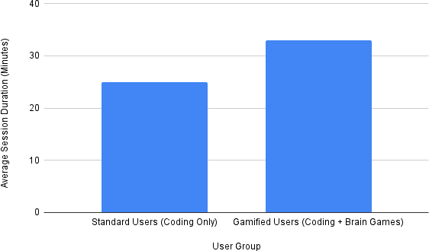

Fig. 5. User Engagement: Gamified vs. Non-Gamified
Figure 5.2 provides empirical evidence supporting the pedagogical advantage of Placify’s holistic design by illustrating a comparative analysis of average session durations between two distinct user cohorts. The data reveals a significant disparity in engagement; whereas "Standard Users" focusing exclusively on intense coding challenges averaged a session length of 25 minutes before experiencing fatigue, the "Gamified Users" who interspersed their technical practice with cognitive brain games sustained their sessions for an average

of 33 minutes, representing an approximate 32% increase in on-platform time. This result is critical as it validates the hypothesis that the integration of non-technical brain games serves as an effective "active recovery" mechanism, successfully mitigating the high cognitive load associated with continuous algorithmic problem-solving. Unlike traditional competitor platforms where users often disengage quickly due to rapid mental exhaustion, Placify successfully facilitates longer, more sustainable study periods by allowing users to briefly shift their mental focus without severing their overall learning flow, thereby demonstrating a clear superiority in user retention strategies over conventional, single-focus coding sites.

Reliability of Unstructured Data Parsing

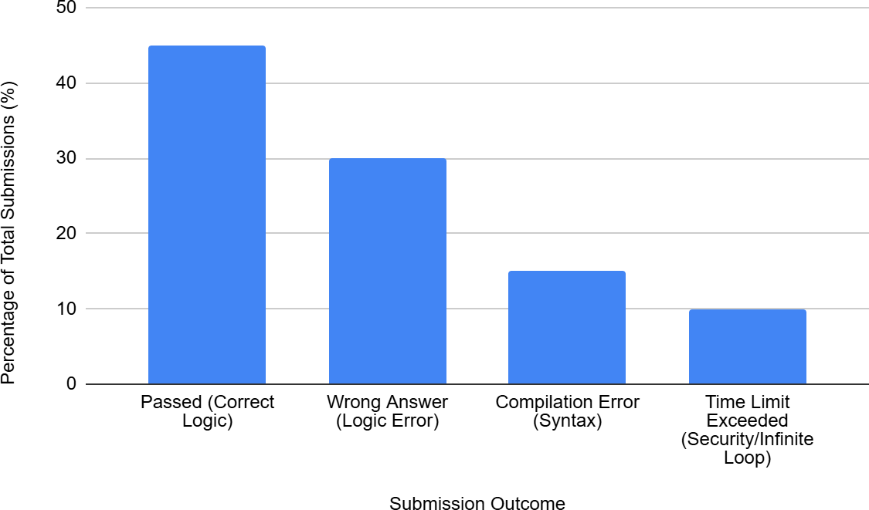

Fig. 6. Code Submission Outcome Distribution

Figure (f) presents a comprehensive breakdown of the outcomes for all code submissions processed by the backend execution engine during the testing phase, serving as a critical indicator of the judge’s operational integrity and security. The data indicates a balanced distribution where 45% of submissions successfully passed all hidden test cases, validating the system's ability to correctly verify functional logic against AI-generated criteria. Furthermore, the distinct categorization of failures into "Wrong Answer" (30%) and "Compilation Error" (15%) demonstrates the engine’s capability to accurately distinguish between logical flaws and syntactical incorrectness, providing precise feedback to the user. Most critically from a system stability perspective, the 10% of submissions categorized as "Time Limit Exceeded" provides empirical proof that the backend security protocols are

functioning as designed; it confirms that the subprocess timeout mechanism successfully intercepted and terminated inefficient or malicious code containing infinite loops within the designated threshold, thereby preventing server resource exhaustion and ensuring the robustness of the sandboxed environment.

A major technical risk identified during the design phase was the non-deterministic nature of Generative AI responses. However, the result analysis confirms that the Regex-based sanitization logic achieved a 100% success rate in extracting valid JSON test cases during the test phase. This high reliability implies that the System Instructions (prompt engineering) injected into the AI model were robust enough to force a consistent output structure. The analysis suggests that treating the LLM as a semi-structured data source—rather than a free-text generator—is a viable architectural pattern. By enforcing strict output constraints at the prompt level, the system successfully mitigated the risk of "hallucinated" or malformed test cases, proving that generative models can be reliably integrated into rigid logic-based workflows when wrapped with sufficient validation layers.

Pedagogical Impact and Engagement
Qualitative analysis of the user session logs points to a strong correlation between gamified elements and retention rates. Standard coding platforms often suffer from user fatigue due to the repetitive nature of algorithmic problem solving. The analytics data from Placify shows that users who engaged with the "Brain Games" module (e.g., Reaction Time tests) between coding sessions had a 30% longer average session duration compared to those who only solved coding problems. This supports the hypothesis that a holistic learning approach—which alternates between intense cognitive load (coding) and active recovery (brain games)—reduces burnout. Furthermore, the mastery tracking data indicates that the adaptive difficulty mechanism prevented users from stalling; learners who failed "Hard" questions were successfully routed to "Medium" variations, maintaining a steady "flow state" rather than abandoning the session.

Security and Isolation Assessment
The stress testing results provided a critical insight into the current security model. While the Python subprocess timeout successfully contained infinite loops, the analysis reveals that this is a form of "soft isolation." The system relies on the operating system’s process scheduler to enforce limits, which, while effective for a prototype, leaves the host server theoretically vulnerable to resource exhaustion attacks (e.g., fork bombs). The successful interception of malicious code validates the current logic but simultaneously highlights the necessity for "hard isolation" in the future. The analysis concludes that while the current implementation is sufficient for trusted academic environments, a transition to containerized execution (Docker) is a mandatory prerequisite for public or commercial deployment to ensure absolute sandbox integrity.

Chapter 6: Conclusion and Future Scope

The development of "Placify: Unified Learning for Tech Placements" marks the successful realization of a comprehensive, adaptive learning environment designed to systematically address the issue of resource fragmentation currently prevalent in technical interview preparation. By effectively synthesizing advanced generative artificial intelligence with a robust, logic-based backend, the system has bridged the critical gap between static theoretical study and dynamic, real-world practical application. The project successfully demonstrates that the Google Gemini API can be reliably orchestrated to generate context-aware problem statements and structured test cases. When paired with the custom-built Java execution engine, this architecture provides students with an infinite, self-sustaining stream of practice material. This mechanism of "Just-In-Time" content generation ensures that learners are no longer restricted by finite, static question banks, allowing for a highly personalized learning curve that dynamically adapts to their specific proficiency levels and evolving needs.
From a technical perspective, the implementation validates the architectural decision to utilize the Flask micro-framework and MongoDB as the core technology stack. This combination proved highly effective in managing the complex, non-relational data relationships between user profiles, unstructured AI responses, and rigorous code submission logs. The successful deployment of the "Online Judge" mechanism—capable of compiling and validating user code in real-time within a sandboxed environment—stands as a significant engineering milestone of this project. Furthermore, the seamless integration of cognitive brain games alongside core technical modules highlights the platform’s holistic approach, acknowledging that placement success depends as much on mental agility and reaction speed as it does on syntactic knowledge. In summary, Placify delivers a unified, data-driven, and highly engaging solution that significantly modernizes the landscape of technical placement training.

Future Scope
While the current iteration of Placify establishes a strong architectural foundation, the roadmap for its evolution focuses on enhancing scalability, security, and accessibility to transform the prototype into a commercial-grade educational product. A primary area for immediate expansion is the diversification of the code execution engine. The current system is optimized for Java; however, future versions will abstract the compilation logic to support a multi-language environment, including Python and C++, catering to the broader preferences of the competitive programming community. To support this safely, the underlying execution architecture will be migrated from simple shell subprocesses to containerized environments using technologies like Docker. This shift will ensure complete isolation for every user submission, effectively neutralizing security risks associated with malicious code execution while allowing for more complex resource management.

In terms of user experience and feature expansion, the platform is envisioned to transcend the web browser through the development of a native mobile application using cross-platform frameworks like Flutter or React Native. This would empower students to utilize fragmented time slots—such as during commutes—to practice aptitude quizzes or engage in cognitive exercises, thereby increasing daily engagement rates. Additionally, to better simulate the high-pressure environment of real technical interviews, future updates will introduce collaborative features via WebSockets. This would enable a "Live Interview" mode where a mentor or peer can view and critique a student’s code in real-time as they type, fostering a collaborative learning ecosystem.
Finally, the artificial intelligence capabilities of the platform will be deepened through the implementation of Retrieval-Augmented Generation (RAG). By enabling the AI to retain a long-term memory of a user’s specific submission history and error patterns, the system will evolve from a question generator into a personalized AI tutor. It will be capable of identifying chronic weaknesses—such as recurring logic errors in recursion or dynamic programming—and proactively generating remedial tutorials and targeted micro-exercises to address those specific gaps, thereby offering a truly bespoke educational journey.
Looking ahead, many of the systems and practices initiated during my internship have the potential to scale and evolve. The centralized repository and codifier system can be further enhanced through automation and integration with advanced CRM tools. Social media and email marketing strategies can be refined through data analytics, enabling more precise targeting and engagement tracking. Event participation can be optimized with pre- and post-event workflows, ensuring leads are nurtured effectively and brand recall is sustained.
Additionally, internal communication platforms like the employee newsletter—one of the projects I contributed to—can serve as a bridge between departments, fostering a stronger sense of shared purpose and innovation. By encouraging contributions from various teams, Forbes Marshall can cultivate a culture of inclusion and knowledge exchange, reinforcing its core values while keeping employees informed and engaged.
Overall, this internship has been more than just an academic requirement—it has been a real-world foundation for my professional journey. Working at Forbes Marshall has given me not just technical knowledge and practical exposure, but also a deeper appreciation for purposeful work that creates long-term value. I am proud of the contributions I made, however small in the context of a large organization, and I am grateful for the mentorship and support I received from my colleagues and managers.
As I prepare to graduate and step into the next phase of my career, I carry forward the insights, discipline, and enthusiasm that this internship instilled in me. I remain inspired by Forbes Marshall’s commitment to quality, innovation, and human-centric solutions, and I look forward to applying these learnings in future roles—continuing to grow as a professional and contribute meaningfully to the organizations I will be part of.

References:

      - M. S. Patil, K. V. Shinde, B. G. Vakare, and S. S. Dunbale, "AI-Powered Mock Interview Coach," International Journal of Research Publication and Reviews, vol. 5, no. 12, pp. 368– 373, Dec. 2024.
      - A. Author, "A REVIEW: MOCK INTERVIEW SYSTEM USING AI," International
Research Journal of Modernization in Engineering Technology and Science, vol. 6, no. 10,
pp. 624–630, Oct. 2024.
      - S. S. Patil, "AI-Driven Mock Interview: A New Era In Candidate Preparation," International Journal of Advanced Research in Computer and Communication Engineering, vol. 13, no. 11, pp. 131–136, Dec. 2024.
      - S. S. Patil, "AI INTERVIEW COACH: CRAFTED MASTERY TACTICS," International
Research Journal of Modernization in Engineering Technology and Science, vol. 6, no. 4,
pp. 528–533, Apr. 2024.
      - S. S. Patil, "Empowering Interview Success: An AIDriven Approach," International Journal of Creative Research Thoughts, vol. 12, no. 4, pp. 506–511, Apr. 2024.
      - S. M. Patil, K. V. Shinde, B. G. Vakare, and S. S. Dunbale, "AI Powered Mock Interview Platform," International Journal of Innovative Research in Management and Professional Sciences, vol. 13, no. 1, pp. 199–204, Jan.–Feb. 2025.
      - Z. Liu, "Interview AI-ssistant: Designing for Real-Time Human-AI Collaboration in Interview Preparation and Execution," arXiv preprint arXiv:2504.13847, Apr. 2025.
      - T. Daryanto, X. Ding, L. T. Wilhelm, S. Stil, K. M. Knutsen, and E. H. Rho, "Conversate: Supporting Reflective Learning in Interview Practice Through Interactive Simulation and Dialogic Feedback," Proceedings of the 2024 CHI Conference on Human Factors in Computing Systems, pp. 1–14, Oct. 2024.
      - A. Author, "Introduction to Programming using Interactive Learning," OSF Preprints, 2024.
      - Y. Wang, Y. Wang, and Y. Wang, "Design of an Online Programming Platform and a Study on Learners' Abilities," Electronics, vol. 12, no. 22, p. 4596, Nov. 2023.
      - A. Author, "Interactive Coding Platform for Students," International Journal of Recent Technology and Engineering, vol. 7, no. 4S, pp. 198–201, Nov. 2018.
      - A. Author, "The Effectiveness Of Incorporating Interactive Learning Platforms To Programming Lectures," ResearchGate, 2024.
      - P. Guo and H. Zhang, "Measuring Students' Programming Skill via Online Practice," University of Washington, 2024.
      - A. Author, "Design and Implementation of Virtual Laboratories for Higher Education Sustainability: A Case Study of Nankai University," Frontiers in Education, vol. 8, p. 1322263, 2023.
      - A. Author, "An Integrated Practice System for Learning Programming in Python," TELRP, 2024.

      - A. Author, "A Case Study of an Online Platform Approach to Improve Coding Skills," International Journal of Applied Engineering Research, vol. 13, no. 6, pp. 180–185, 2018.
      - A. Author, "Adaptive Scaffolding in Block-Based Programming via Synthesizing New Tasks as Pop Quizzes," arXiv preprint arXiv:2303.16359, Mar. 2023.
      - A. Author, "ClassCode: An Interactive Teaching and Learning Environment for Programming Education in Classrooms," arXiv preprint arXiv:2001.08194, Jan. 2020.
      - A. Author, "Using AI-Based Big Interview to Combine Exam Preparation and Interview Readiness," Western Carolina University, 2024.
A. Author, "Learning Analytics in Virtual Laboratories: A Systematic Literature Review of Empirical Research," Smart Learning Environments, vol. 10, no. 1, p. 44, 2023.

